**PYTHON CODING CHALLENGE**

**ORDER MANAGEMENT SYSTEM**

**HARSHINI V**

* 1. **OUTPUT SCREENSHOTS:**
  2. **1. Creating a user**
  3. 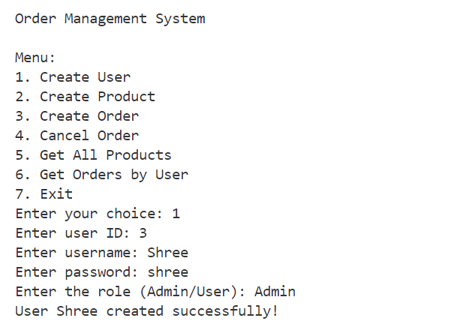
  4. **2. Creating a product**
  5. **a. Product under Clothing category**
  6. 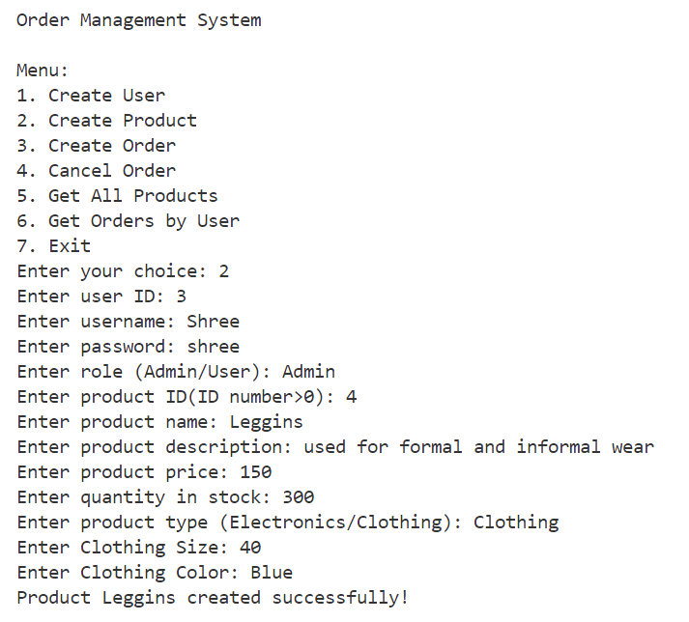
  7. **b. Product under Electronics category**
  8. 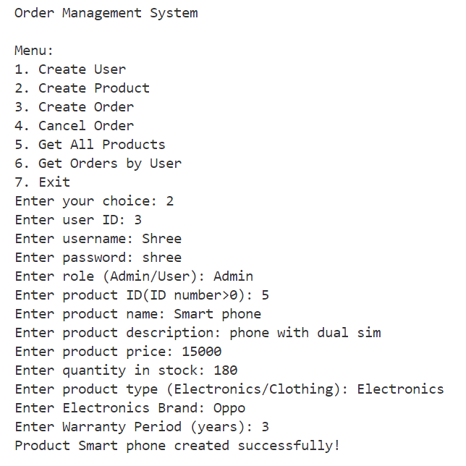
  9. **3. Creating an order for the user**
  10. 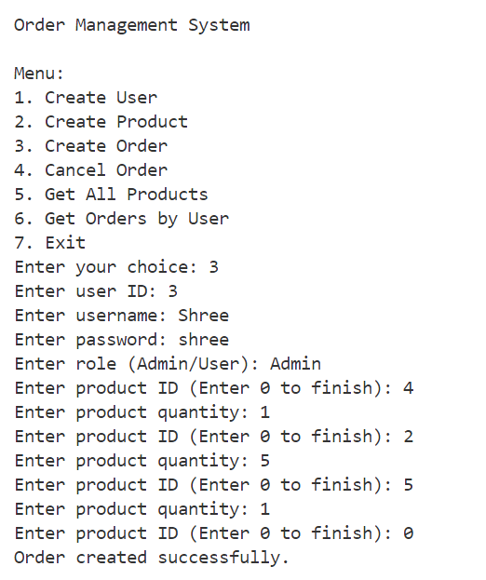
  11. **4. Cancelling an order created by a user**
  12. 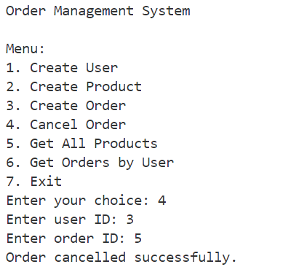
  13. **Checking whether the order cancelled or not**
  14. 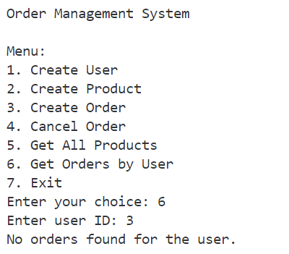
  15. **5. Showing all the products create by the user**
  16. 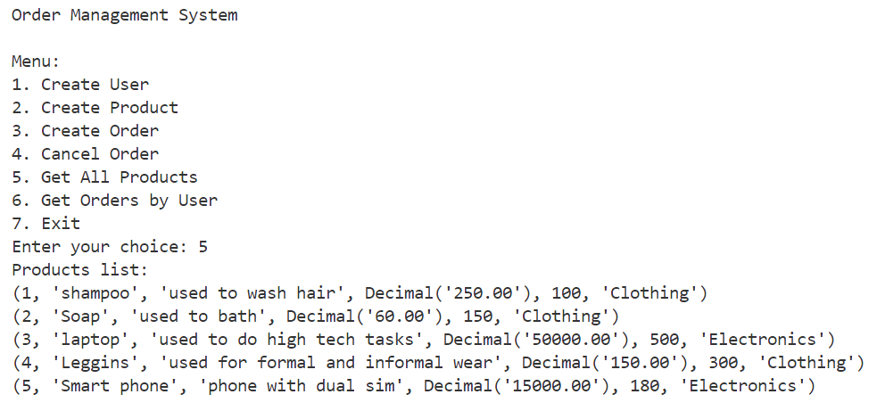
  17. **6. Showing all the orders created by the user**
  18. 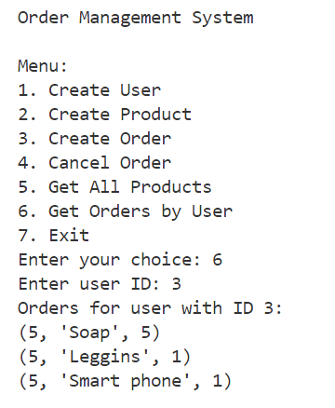
  19. **7. Exiting the process**
  20. 